|  |
| --- |
| **AISC2000 – Machine Learning 2**  Module 13 – Application Exercise  Group F  *Charitha Priya Dongari – 500191110*  *Katterapalli Venkata Satya Narayana Reddy – 500190693*  *Rumana Banu Iliyas Ahmed – 500186725*  *Rohan Bhatt – 500187633*  *Shivam Jolly – 500196452* |

**Please consult Neural Networks lecture and the suggested LinkedIn Learning courses at Moodle to complete this activity.**

**You may use Python to complete Step 5 to 7. You are recommended to comment your code properly.**

1. **What is Face Recognition and how it relates to Neural Networks? You can provide an example dataset used for face recognition, then, specify input/output to the neural network and the problem being solved by the network.**

The capacity to recognizing a person's face from a digital image is known as facial recognition. Here, we train the algorithm to recognize a person's face that we already know this is also known as identification verification.

Neural-networks for face recognition are used to recognize the faces. They learn to classify the faces presented to them by training on the pictures of the face. The input of the image is calculated by bits of arrays and output is also given by the same. We use Euclidean Distance to compare the known pictures with the unknown pictures.

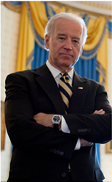

INPUT

Input: - A digital Image converted to list of 128d (128 real valued numbers). The below image represents the 128 real valued number of the above Joe Biden pic.



Output: - Classification label for that image to list of 128d (128 real valued numbers).

After building our model on the above picture, now if we give any picture consisting Joe Biden, it will show the following output.

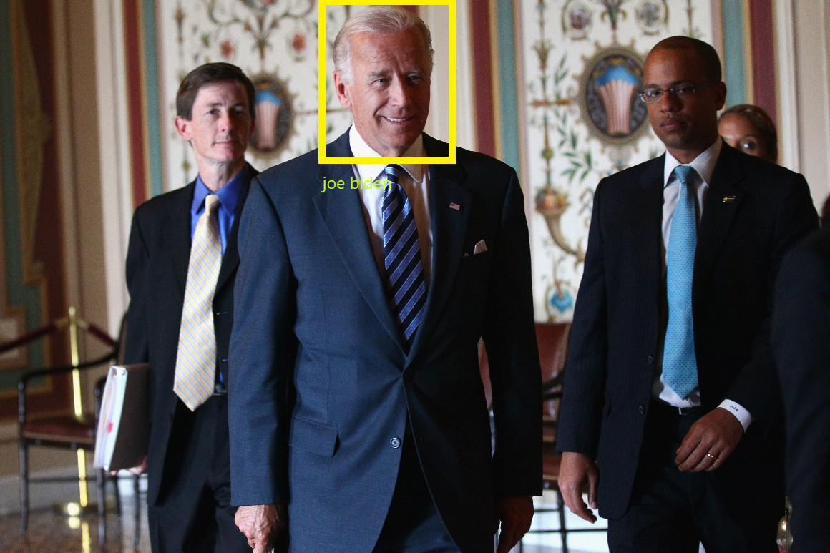

1. **How Face Recognition can be used to measure the effectiveness of an advertising billboard?**

To measure the effectiveness of billboard means, to check if the major proportion of its targeted audience compared with the normal audience present in front of the billboard. We can install cameras on the billboards, we can use face recognition to recognize the mood and ages of the audience present right in front of the billboard.

1. **Imagine you are running a face recognition system and it is not working properly for a specific image. Which way do you suggest to debug and track the problem? Tip: you may think of different steps in face recognition pipeline and consider the step that most likely causes this problem.**

There are two issues that we could encounter while trying to implement face recognition. The first one is the syntax error. The second one is one of the internal steps of face recognition. Face recognition consists of three major activities – face recognition, landmark of faces, face comparison. We got through each section separately and check the outputs to eventually debug the error.

1. **Explain how Euclidean Distance measure can be used in Face Recognition.**

Euclidean distance is calculated as distance between set of two-points. Here, in face recognition we use the same calculation but in slightly different. You will need to convert the items to feature vectors so that they can be compared to two faces.

To get the values for each image, store them in a vector and then apply the Euclidean distance. Each feature is represented as a point within the feature space.

Get the values for each image by storing them in a vector and applying the Euclidean distance.

1. **Use an image from folder “Step 5”, then, write a code to detect faces in the image, print the number of detected faces on the screen and finally, draw a rectangle around their faces.**

Here we have taken the picture from the step5 folder and detected the number of faces present in the picture.

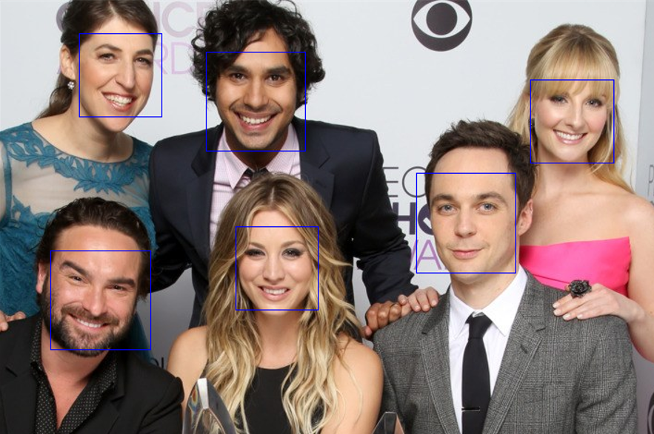

1. **Then, extend the code from Step 5 such that it detects individual landmarks in every face in the image and draws lines representing those landmarks.**

Here, we have used the landmarks function do draw the patterns in the picture as shown in the below.

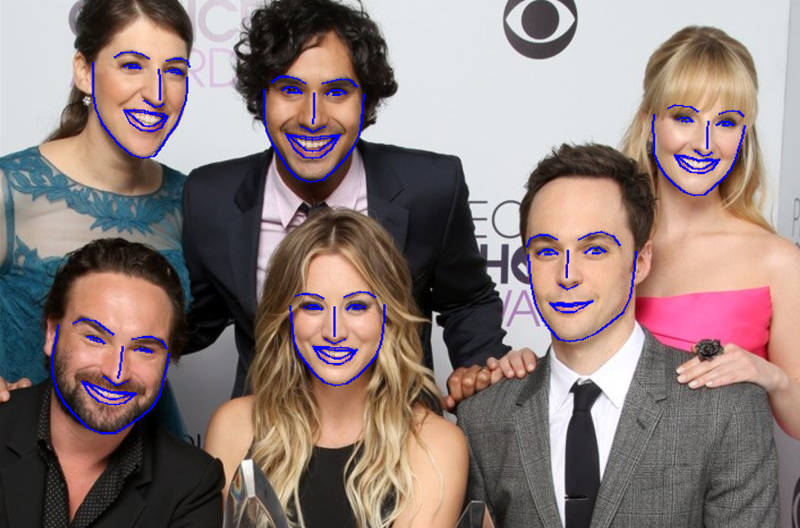

1. **In this step, you must use the provided sample dataset and known image in folder “Step 7” to code a face recognition system. The system must be able to find a match in the dataset for “John.jpg” and print out how many times John gets a match in the dataset.**

Finally, we have taken the dataset with 8 unknown images and 1 known image.

And compared the known person john with the other 8 unknown images and provided the number of times he is present in the other 8 images.

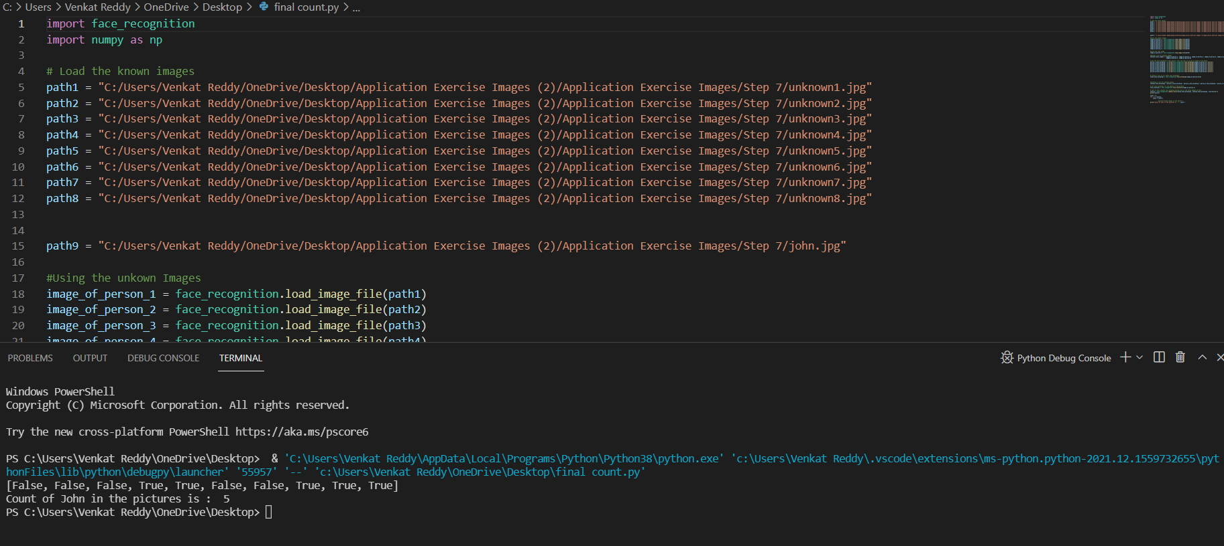

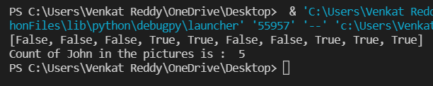

**REFERENCES**

* <https://www.dailymail.co.uk/news/article-6969213/Billboards-spying-shoppers-facial-recognition-cameras-detect-ages-mood.html>
* <https://www.linkedin.com/learning/deep-learning-face-recognition/tools-for-face-recognition?autoAdvance=true&autoSkip=false&autoplay=true&resume=true&u=2148769>